

**Operating System**

**Lab # 11**

**Name: Adeesha Sherani**

**Sap Id: 47379**

**Batch: BSCS 5thsem**

**Submitted to: Mam Kausar**

**Q1. How do you create a basic forloop in a shell script to iterate over a list of numbers from**

**1 to 5?**

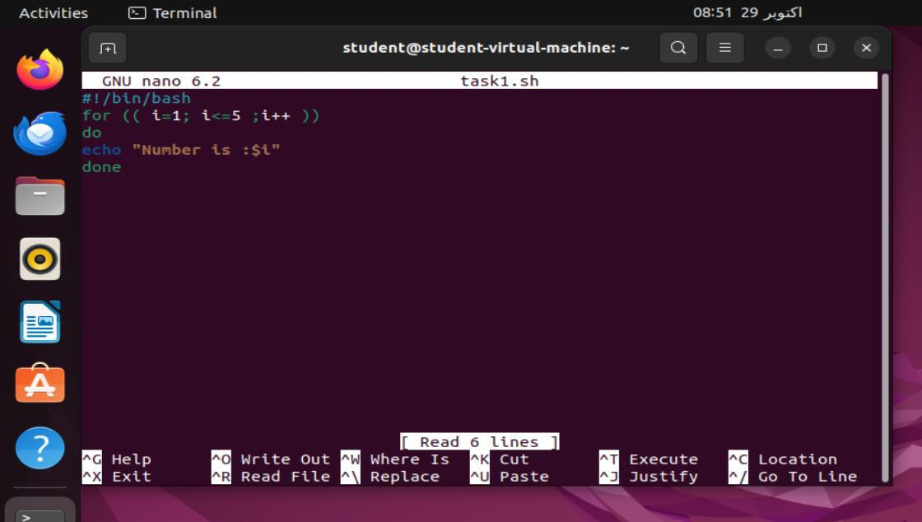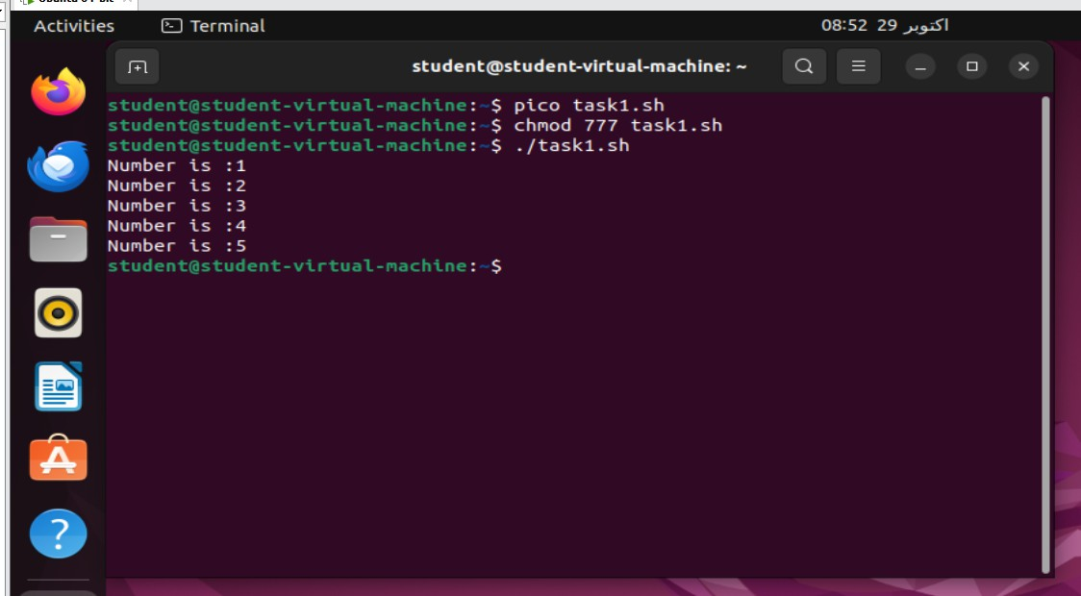

**Q2. What is the syntax for a whileloop that counts from 1 to 10 and prints each numb**

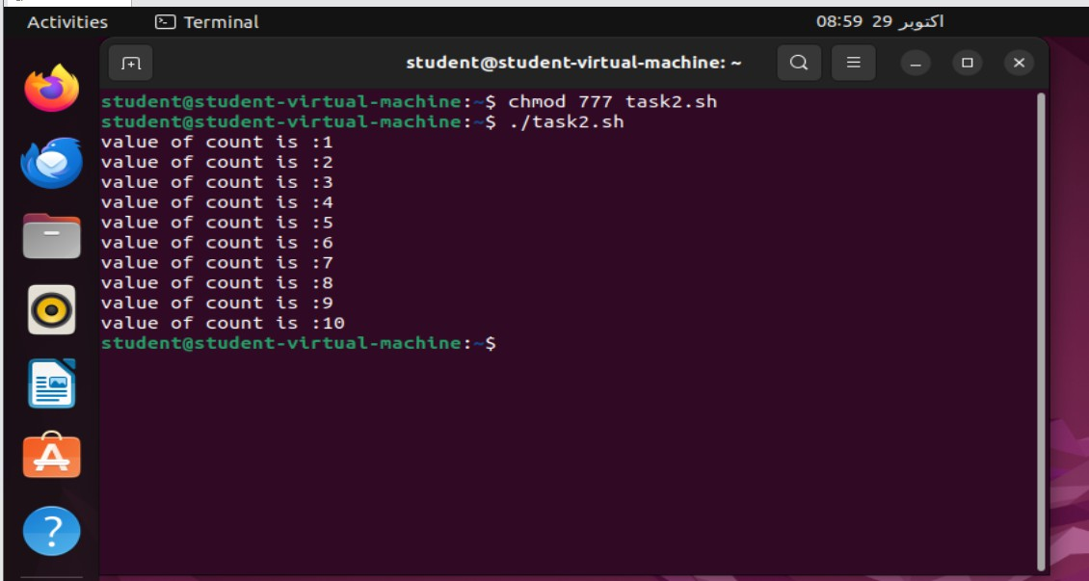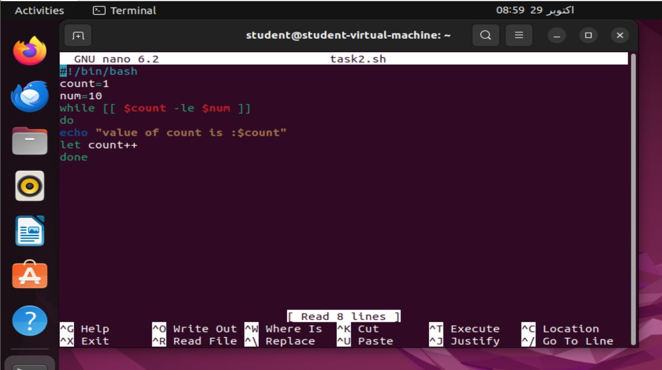

**Q4: Write a for-in loop that iterates over the items in an array named fruits**

**containing apple, banana, and cherry.**

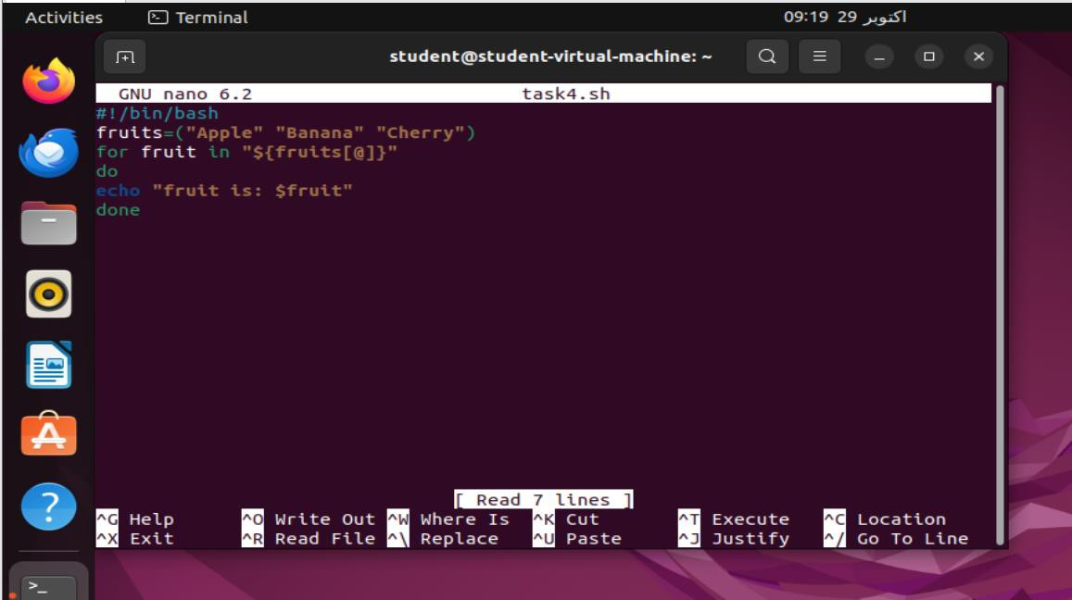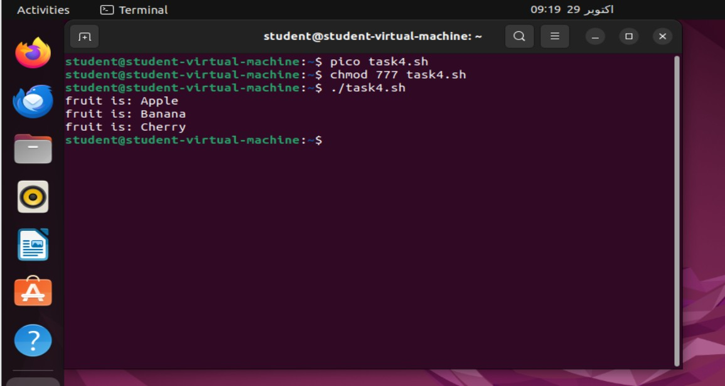

**Q3. How would you write a nested loop in shell scripting to print a multiplication table from**

**1 to 3?**

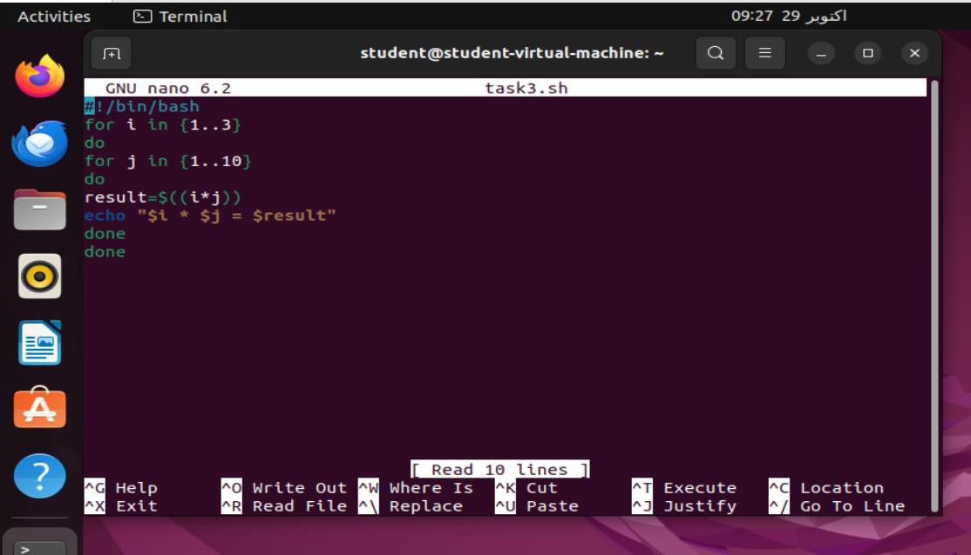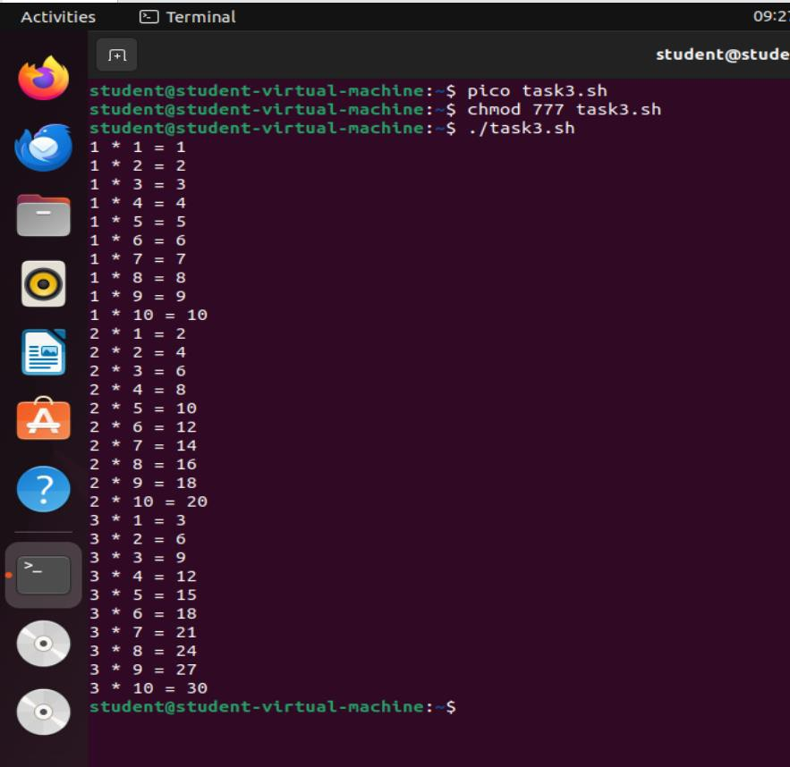

**Q5: Write a whileloop that reads user input until the user types "exit".**

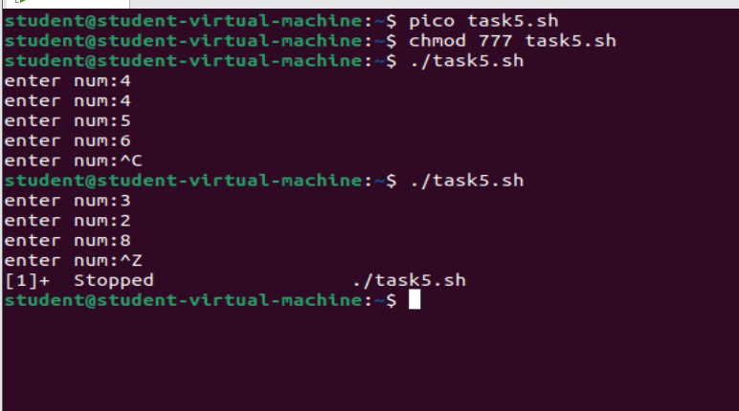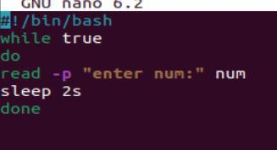

Task 1: Explanation:

for ((i=1; i<=5; i++)): This initializes the variable i to 1. The loop runs as long as i is less than or equal to 5. After each iteration, the value of i is incremented by 1.

echo "$i": This prints the current value of i to the console.

done: Marks the end of the for loop.

Task 2: Explanation:

The variable count is initialized to 0 to act as a counter.

The variable num is set to 10, which will be the upper limit for the counter.

A while loop starts with the condition [ $count -le $num ], meaning the loop will continue running as long as count is less than or equal to num. (-le stands for "less than or equal to.")

After executing the loop's body, count is incremented by 1.

The loop stops when count becomes greater than num (i.e., 11).

Task 3: Explanation:

for i in {1..3}: This outer loop iterates through the numbers from 1 to 3, representing rows of a multiplication table.

for j in {1..3}: The inner loop also runs from 1 to 3, representing columns.

result=$((i * j)): Calculates the product of i and j.

echo "$i * $j = $result": Prints the result of multiplying i by j.

Task 4: Explanation:

An array named fruits is defined with three elements: "apple", "banana", and "cherry".

A for loop is used to iterate through each element in the fruits array.

During each iteration, the loop variable holds the value of the current fruit.

Inside the loop, the current fruit is printed to the console.

Task 5: Explanation:

The code prompts the user to enter a number with the message "Enter num :".

The input entered by the user is stored in the variable num.

The loop will keep asking the user to enter numbers until the user decides to exit.